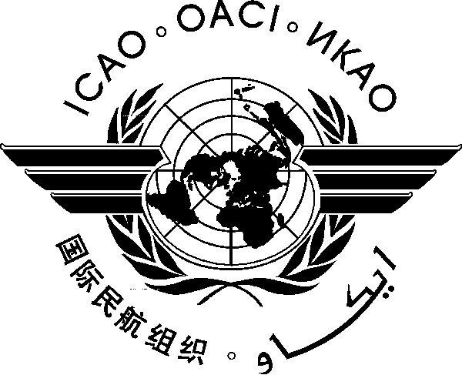International Civil Aviation Organization
Asia Pacific Regional Aviation Safety Team - Third Meeting of the
Accident Investigation Ad hoc Working Group (APRAST-AIG AWG/3)
(Bangkok, Thailand, 11 – 12 March 2013)

Programme
Monday, 11 March 2013
08:30 – 09:00 | - Registration
09:00 – 09:15 | - Meeting Arrangements and Adoption of Agenda  - Opening remarks and welcome  (Chairman and Secretariat)
09:15 – 09:30 | - Self-introduction of participants  Photo-taking
09:30 – 10:00 | Tea Break
10:00 – 12:00 | - Agenda Item 1: Review of the outcome of the RASG-APAC/2 Meeting in respect of the recommendations by the APRAST-AIG AWG  WP/1: Adoption of the APRAST-AIG AWG/3 agenda  IP/2: RASG-APAC decision on APRAST–AIG AWG’s recommendations – Chairman  IP/3: Follow-up to RASG-APAC’s approval of APRAST–AIG AWG’s recommendations – Chairman  - Agenda Item 2: Review of responses of States/Administrations to an ICAO APAC survey on matters related to accident/incident investigation  IP/4: Accident/Incident Investigation Related Matters Survey Results – Singapore
12:00 – 13:00 | Lunch
13:00 – 15:00 | - Agenda Item 3: Formation of the APAC Group of Experts on Accident/Incident Investigation (APAC-ACC)  WP/2: APAC Group of Experts on Accident/Incident Investigation - Implementation Plan – Singapore
15:00 – 15:30 | Tea Break
15:30 – 16:30 | - Agenda Item 4: Asia-Pacific Code of Conduct on Cooperation Relating to Civil Aviation Accident/Incident Investigation  IP/5: Updates on Accession to the Asia-Pacific Code of Conduct on Cooperation Relating to Civil Aviation Accident/Incident Investigation - ICAO Secretariat  WP/3: Clarification on the Asia-Pacific Code of Conduct on Cooperation Relating to Civil Aviation Accident/Incident Investigation - Chairman/Vice Chairman  WP/4: Accession to the Asia-Pacific Code of Conduct on Cooperation Relating to Civil Aviation Accident/Incident Investigation – Singapore
Tuesday 12 March 2013

09:00 – 10:00 | - Agenda Item 5: Review of the Action Plan to improve the accident/incident investigation capability in the APAC region  WP/5: Development of a new Aircraft Accident Investigation Facility in Hong Kong - Hong Kong, China  WP/6: APRAST-AIG AWG’s Action Plan – Singapore
10:00 – 10:30 | Tea Break
10:30 – 12:00 | - Agenda Item 6: Other Business  WP/7: Matter referred to APRAST-AIG AWG by RASG-APAC/2 – Chairman  WP/8: Improving the Fire Detection Systems of Aircraft Cargo Compartment – Republic of Korea  WP/9: Improving Fire Detection Systems of Aircraft Cargo Compartment – Singapore  - Review of discussions and possible proposals for RASG-APAC
12:00 – 13:00 | Lunch
13:00 – 15:00 | - Review of discussions and possible proposals for RASG-APAC (Cont’d)  - Review of Draft Report of the Meeting
15:00 – 15:30 | Tea Break
15:30 – 15:50  15:50 – 16:00 | - Review of Draft Report of the Meeting (Cont’d)  - Closing of the Meeting

— END —

